Project 2: Movie Info Page

Submitted by:

Anisha Divi R (2460329)

Krinitha R (2460393)

Sarvani Pathangi (2460447)

Course: UI/UX Design fundamentals

Instructor Name: Dhiraj

Institution: Christ University

Date of submission:13/08/2025

Abstract

The Movie Info Page is a web-based project designed to provide users with detailed information about movies in an organized and visually appealing manner. This page displays essential movie details such as title, release year, genre, cast, director, synopsis, and ratings. The layout is crafted using HTML and styled with CSS to ensure a responsive and user-friendly experience across devices. The project aims to enhance users' ability to quickly access comprehensive movie data in one place, making it useful for movie enthusiasts, reviewers, and casual viewers alike. Additionally, interactive elements like trailers, posters, and related movie suggestions may be included to enrich user engagement.

**Objectives**

To design a visually appealing and user-friendly movie information page using HTML and CSS. To present comprehensive movie details including title, genre, release year, cast, director, synopsis, and ratings in a structured format. To ensure the webpage is responsive and accessible on various devices such as desktops, tablets, and smartphones.

To incorporate multimedia elements such as movie posters and trailers for an engaging user experience.

To implement easy navigation within the page for quick access to different sections of movie information.

To create a scalable template that can be easily updated with new movies or additional information.

**Scope of the Project**

The project focuses on creating a single web page that displays detailed information about one or multiple movies in a clean and organized layout.

It includes static content such as movie titles, release dates, genres, cast, directors, synopsis, and ratings.

The page will support images like movie posters and may embed trailers using video links (e.g., YouTube).

The design will be responsive, ensuring usability across different screen sizes and devices.

The project is limited to front-end development using HTML and CSS, with optional inclusion of basic JavaScript for minor interactivity like navigation or media controls.

It will not include dynamic data fetching from external databases or APIs (unless specified), focusing primarily on showcasing information in a presentable format.

The scope may extend to allow manual updates or additions of movies by modifying the HTML content.

**Tools & Technologies Used**

HTML5 – For structuring the content and elements of the movie info page.

CSS3 – For styling the page, including layout, colors, fonts, and responsiveness.

Responsive Design Techniques – Using CSS Flexbox/Grid and Media Queries to ensure the page works well on different screen sizes.

Text Editor/IDE – Such as Visual Studio Code, Sublime Text, or Atom for writing and managing code efficiently.

Web Browser – Like Google Chrome, Firefox, or Edge for testing and previewing the web page.

Image Editing Tools (optional) – Tools like Photoshop, GIMP, or online editors to prepare movie posters or graphics.

Version Control System (optional) – Git and GitHub for managing code versions and collaboration.

Basic JavaScript (optional) – For adding simple interactivity like media controls or navigation enhancements.

**Semantic Tags Used**

<header> — To contain the main page heading or the movie title section.

<nav> — If you have navigation links (like Home, Genres, About, etc.) or menu.

<main> — To wrap the primary content of the movie information page.

<section> — To divide different parts such as Synopsis, Cast, Reviews, or Ratings.

<article> — To represent an individual movie’s details if the page lists multiple movies.

<aside> — For related content like trailers, related movies, or advertisements.

<figure> — To hold movie posters or images, possibly with <fig caption> for image description.

<footer> — To include page footer info such as copyright, contact, or credits.

**HTML Structure Overview**

The personal portfolio website is built using semantic HTML5 tags to create a well-organized and meaningful document structure. Key tags such as <header>, <nav>, <main>, <section>, and <footer> are used to clearly define different parts of the webpage, enhancing both accessibility and SEO.

The website is divided into reusable and clearly defined sections including About, Projects, and Contact. Each section is wrapped inside a <section> tag within the <main> element, making it easy to manage content and style each part individually.

The navigation menu is implemented using an unordered list (<ul>) inside the <nav> element, with each menu item as a list item (<li>) containing anchor (<a>) links. These links point to the corresponding sections on the page, enabling smooth scrolling navigation and improving the user experience by allowing quick access to different parts of the portfolio.

Code:

<!DOCTYPE html>

<html lang="en">

<head>

<meta charset="UTF-8" />

<meta name="viewport" content="width=device-width, initial-scale=1.0" />

<title>Howl’s Moving Castle</title>

<link href="https://fonts.googleapis.com/css2?family=Libertinus+Sans:ital,wght@0,400;0,700;1,400&family=Playwrite+AU+QLD:wght@100..400&

display=swap" rel="stylesheet">

<style>

body {

margin: 20;

font-family: 'Libertinus Sans', sans-serif;

background-color: #121212;

color: #fff;

}

header {

text-align: center;

padding: 2rem;

background: #1c1c1c;

}

.banner {

background: url('header.jpeg') center/cover no-repeat;

height: 50vh;

position: relative;

}

.banner .overlay {

background-color: rgba(0, 0, 0, 0.6);

height: 100%;

display: flex;

align-items: center;

justify-content: center;

}

.synopsis, .cast, .reviews, .watch, .gallery, .movie, . {

padding: 2rem;

}

.movie-grid {

display: grid;

grid-template-columns:repeat(auto-fit, minmax(150px, 1fr));

gap: 1rem;

}

.movie-card {

background: #1e1e1e;

border-radius: 12px;

padding: 2rem;

text-align: center;

box-shadow: 0 4px 10px rgba(0,0,0,0.3);

}

.movie-card img {

width: 100%;

height: 500px; /* or whatever height works best */

object-fit: cover;

border-radius: 10px 10px 0 0; /* keep rounded top corners */

}

.cast-grid {

display: grid;

grid-template-columns:repeat(auto-fit, minmax(150px, 1fr));

gap: 1rem;

}

.cast-card {

background: #1e1e1e;

border-radius: 12px;

padding: 2rem;

text-align: center;

box-shadow: 0 4px 10px rgba(0,0,0,0.3);

}

.cast-card img {

width: 100%;

height: 250px; /* or whatever height works best */

object-fit: cover;

border-radius: 10px 10px 0 0; /* keep rounded top corners */

}

}

.reviews {

margin-top: 3rem;

}

.reviews-section h2 {

color: white;

margin-bottom: 1rem;

}

.reviews-row {

display: flex;

gap: 1rem;

overflow-x: auto; /* horizontal scrolling */

padding-bottom: 0.5rem;

scroll-behavior: smooth; /* smooth scroll when using mouse wheel/trackpad */

}

.reviews-row::-webkit-scrollbar {

height: 8px;

}

.reviews-row::-webkit-scrollbar-thumb {

background: #555;

border-radius: 4px;

}

.reviews-row::-webkit-scrollbar-thumb:hover {

background: #777;

}

.review-card {

flex: 0 0 auto; /* prevent shrinking, keep card size */

width: 250px;

background: #1e1e1e;

padding: 2rem;

border-radius: 12px;

box-shadow: 0 4px 10px rgba(0,0,0,0.3);

}

.review-card p {

margin: 0;

color: #ddd;

font-size: 0.95rem;

}

.review-card span {

display: block;

margin-top: 0.3rem;

font-size: 0.85rem;

color: #aaa;

}

.stars {

color: gold;

font-size: 1.2rem;

}

/* New gallery styles */

.gallery {

background-color: #111;

text-align: center;

}

.gallery-grid {

display: grid;

grid-template-columns:

repeat(auto-fill, minmax(250px, 1fr));

gap: 20px;

margin-top: 20px;

}

.gallery-grid img {

width: 100%;

height: auto;

border-radius: 10px;

box-shadow: 0 4px 8px rgba(0,0,0,0.4);

transition: transform 0.3s ease;

}

.gallery-grid img:hover {

transform: scale(1.05);

}

footer {

background: #000;

text-align: center;

padding: 2rem;

}

footer img {

max-width: 100px;

}

</style>

</head>

<body>

<!-- Header -->

<header>

<h1>Howl’s Moving Castle</h1>

<p>Animation • Fantasy • 2004</p>

</header>

<!-- Banner -->

<section class="banner">

</section>

<!-- Synopsis -->

<section class="synopsis">

<h2>Plot</h2>

<p>Sophie (Emily Mortimer) has an uneventful life at her late father's hat shop, but all that changes when she befriends wizard Howl (Christian Bale), who lives in a magical flying castle.</p>

<p> However, the evil Witch of Waste (Lauren Bacall) takes issue with their budding relationship and casts a spell on young Sophie, which ages her prematurely.</p>

<p> Now Howl must use all his magical talents to battle the jealous hag and return Sophie to her former youth and beauty.</p>

</section>

<!-- Cast -->

<section class="cast">

<h2>Cast</h2>

<div class="cast-grid">

<div class="cast-card">

<img src="howl.jpeg" alt="Actor 1" />

<p><strong>Takuya Kimura

</strong>

<br/>Howl(voice)</p>

</div>

<div class="cast-card">

<img src="sophie.jpeg" alt="Actor 2" />

<p><strong>Chieko Baishô

</strong>

<br/>Sophie(voice)</p>

</div>

<div class="cast-card">

<img src="calcifer.jpeg" alt="Actor 2" />

<p><strong>Tatsuya Gashûin

</strong>

<br/>Calcifer(voice)</p>

</div>

<div class="cast-card">

<img src="witch.jpeg" alt="Actor 2" />

<p><strong>AkihiroMiwa

</strong>

<br/>Witch of the Waste(voice)</p>

</div>

</div>

</section>

<section class="movie">

<h2>Crew</h2>

<div class="movie-grid">

<div class="movie-card">

<img src="director.jpeg" alt="production 1" />

<p><strong>HayaoMiyazaki

</strong>

<br/>Director,Screenplay</p>

</div>

<div class="movie-card">

<img src="author.jpeg" alt="production "3 />

<p><strong>Diana Wynne Jones

</strong>

<br/>novel "Howl's Moving Castle"</p>

</div>

</div>

</section>

<!-- Reviews -->

<section class="reviews">

<h2>User Reviews</h2>

<div class="reviews-row">

<div class="review-card">

<div class="stars">★★★★★</div>

<p>"Amazing movie! The cinematography was breathtaking."</p>

<span>- Alex</span>

</div>

<div class="review-card">

<div class="stars">★★★☆☆</div>

<p>"The pacing was a bit slow, but the story was great."</p>

<span>- Jamie</span>

</div>

<div class="review-card">

<div class="stars">★★★★☆</div>

<p>"Loved the performances, especially the lead actor!"</p>

<span>- Taylor</span>

</div>

</div>

</section>

<!-- Gallery -->

<section class="gallery">

<h2>Gallery</h2>

<div class="gallery-grid">

<img src="1.jpeg" alt="Scene 1">

<img src="2.jpeg" alt="Scene 2">

<img src="3.jpeg" alt="Scene 3">

<img src="4.jpeg" alt="Scene 4">

<img src="5.jpeg" alt="Scene 5">

<img src="6.jpeg" alt="Scene 6">

<img src="7.jpeg" alt="Scene 7">

<img src="8.jpeg" alt="Scene 8">

<img src="9.jpeg" alt="Scene 9">

<img src="10.jpeg" alt="Scene 10">

</div>

</section>

<!-- Where to Watch -->

<section class="watch">

<h2>Where to Watch</h2>

<ul>

<li>Netflix</li>

<li>HBO MAX</li>

</ul>

</section>

<!-- Footer -->

<footer>

<img src="logo.png" alt="Studio Logo" />

<p>© 2025 studio ghibli </p>

</footer>

</body>

</html>

Output:

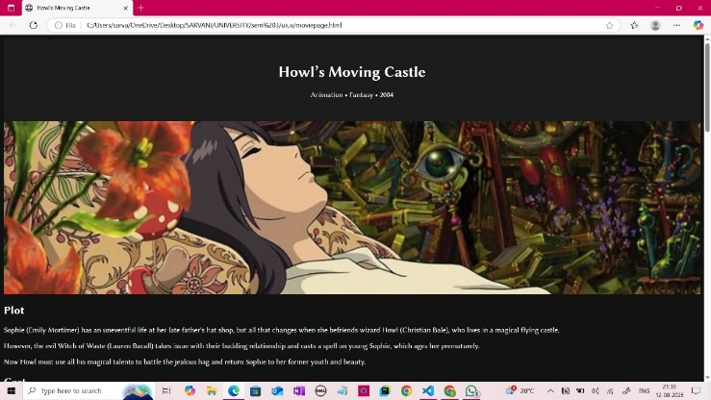

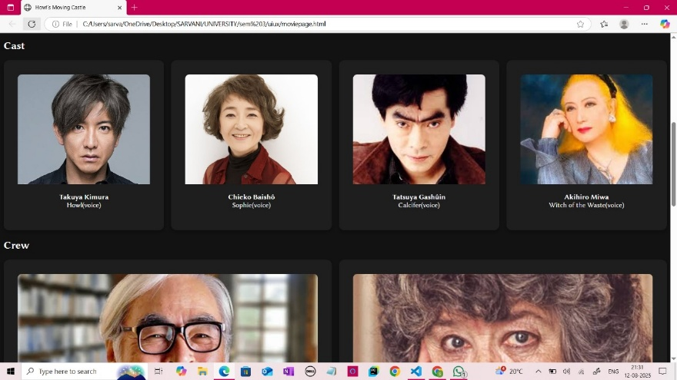

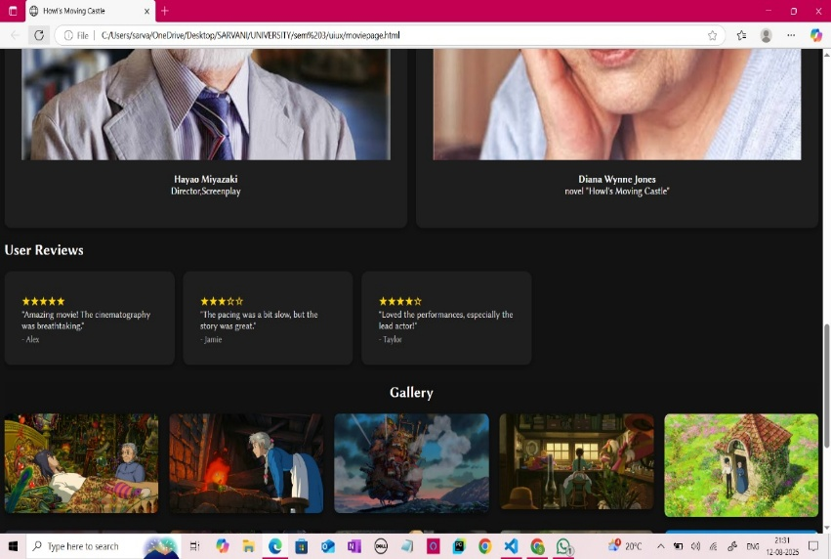

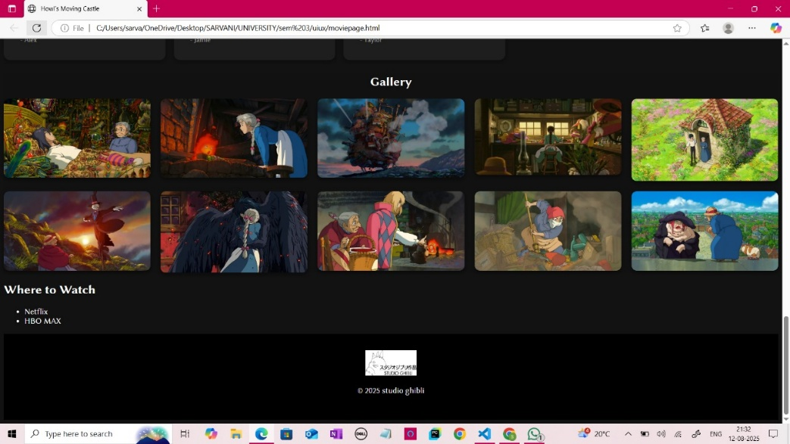

**Conclusion:**

The Movie Info Page project successfully demonstrates the creation of a structured and visually appealing web page using HTML and CSS. It effectively presents essential movie details in an organized manner, enhancing the user’s ability to access and understand movie information quickly. The responsive design ensures accessibility across various devices, improving overall user experience. This project lays a solid foundation for further enhancements, such as adding interactivity with JavaScript or integrating dynamic data sources, making it a practical and engaging tool for movie enthusiasts.

**Future Enhancements:**

1. **Dynamic Data Integration:** Connect the page to a movie database API (like OMDb or TMDb) to fetch real-time movie details automatically.
2. **Search and Filter Functionality:** Allow users to search for movies by title, genre, or year and filter results dynamically.
3. **User Reviews and Ratings:** Enable users to submit their own reviews and rate movies directly on the page.
4. **Interactive Elements:** Add JavaScript-powered features like tabs, accordions for sections (cast, reviews), and video lightboxes for trailers.
5. **Multi-movie Listing:** Expand the page to display multiple movies with clickable cards leading to detailed info pages.
6. **Improved Accessibility:** Enhance accessibility features for users with disabilities, including keyboard navigation and screen reader support.
7. **Backend Integration:** Develop a backend system for managing movie data, user accounts, and personalized recommendations.
8. **Social Media Sharing:** Add options to share movie info or reviews on social platforms easily.
9. **Dark Mode:** Implement a toggle for light/dark themes to improve usability in different lighting conditions.